**Crop Cultivation Patterns for Critical Adaptations to Agricultural Systems and Policy**

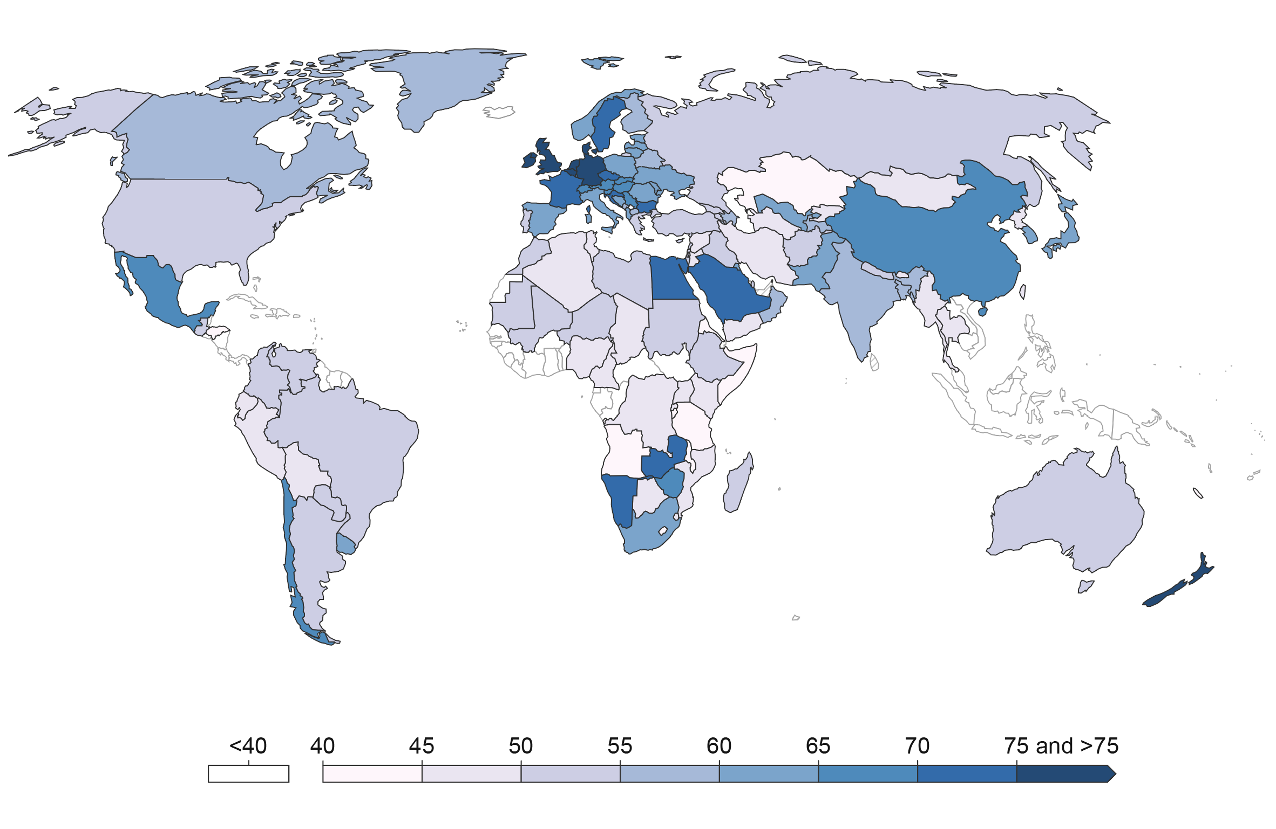

Figure S1: Geographical distribution and percentage coverage of the study.

Grains had the maximum share in South America according to the yield anomaly anlaysis of the study. Europe and Africa were in the second position concerning grains-share in their agricultural productions. However, South America had the lowest nuts production among all the continents. North America showed a little more resistance toward food security issues as it was least dependent on grain production. However, the Asian countries had the maximum share of vegetables in the yield anomaly of their agricultural produce, which was the second most sensitive crop group toward extreme climates. Tubers were the most resistant crop type in tolerating extreme climates, and tuber yield anomaly showed their highest production in Asia and Australia. Three major crop types in Australia were tubers, nuts, and oilseed, among which tubers and nuts were the least sensitive to extreme climates (Figure S2).

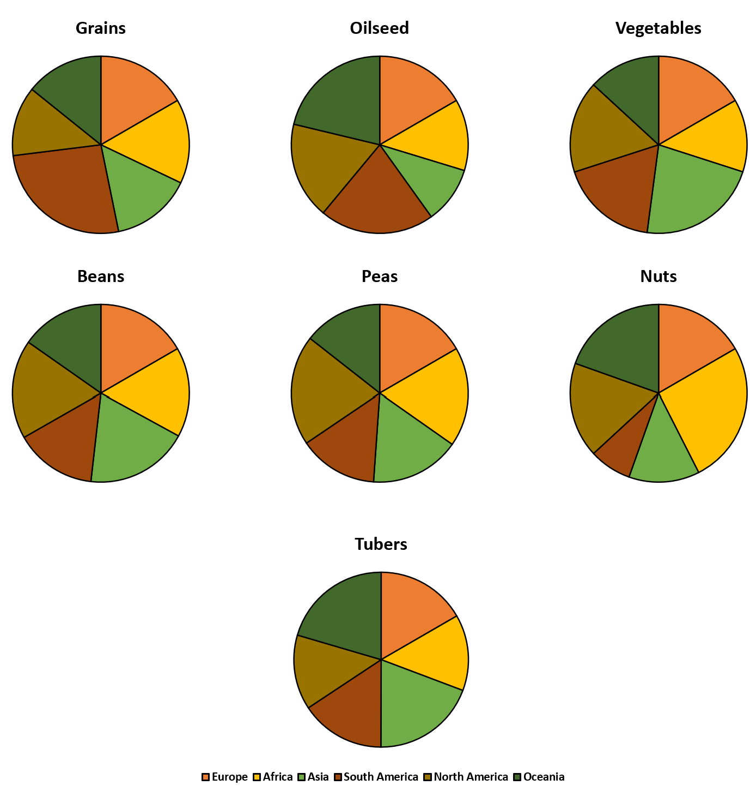

Figure S2: Percentage yield anomaly of different crop types in different continents of the world.

Overall, the high temperature was responsible for the early phenology shift. However, it mainly expanded the total period of seed emergence. Although an earlier phenology trend was recorded in the case of HT, it was a non-significant difference in comparison to other phenophases shifts. The high temperature caused significant earlier phenology in the rest of the three phenophases (i.e., vegetative, reproductive, and maturity). The impact of low temperature was exactly opposite to the high temperature when it induced delayed phenology in all the same four phenophases. Drought and wind caused a delayed emergence, but they caused the early occurrence of the other three phenophases. High precipitation induced early emergence from the seeds, but at the later life stages, it delayed the phenophases, especially in the case of vegetative phenophase, where it caused the highest delay in phenophase than any other extreme climate factor (Figure S3).

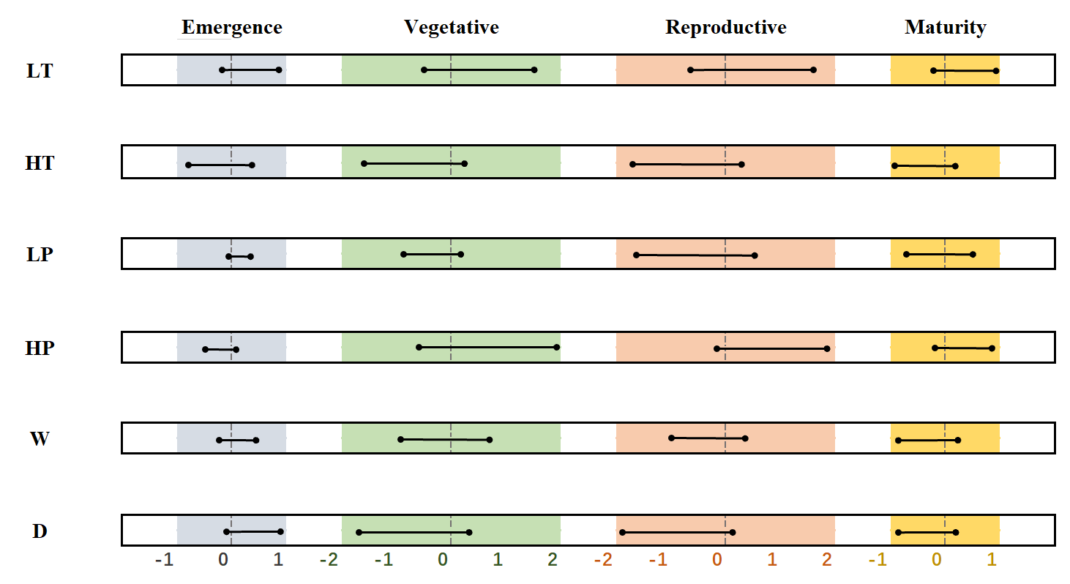

Figure S3: Phenological shifting analysis in response to different types of extreme climates.

The airflow simulation of double-row windbreak trees proved no significant benefit with respect to increasing the cultivation area. The only difference calculated was the 1*d* increment in the safe cultivation area in the case of double-row plants. However, that can also be neglected due to the increased number of trees in the second row of the trees input in airflow simulation. Therefore, it can be considered that the resultant safe cultivation areas were almost similar to each other (for a single-row and a double-row windbreak). The details can be seen in Figure S4 and the supplementary airflow simulation.

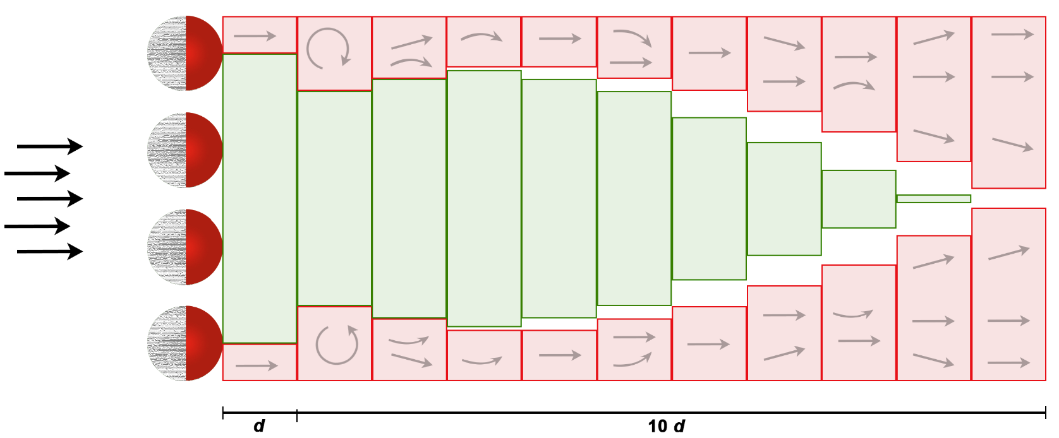

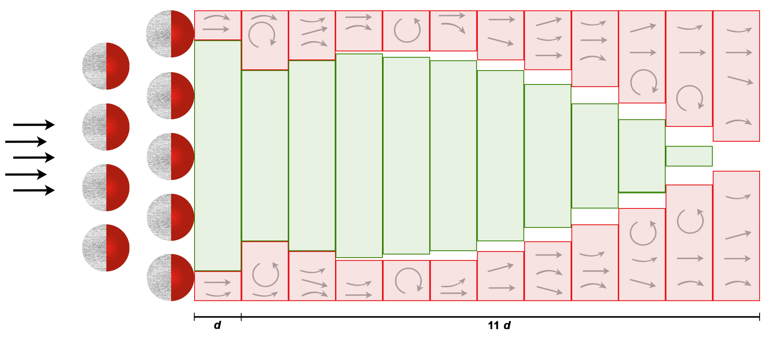

Figure S4: Vertically dimensioned plotting area analysis by following the airflow patterns around a single row of plants (A) and a double row of plants (B). Note: section A is part of the main manuscript file. It has been provided here for a real-time comparison.

Table S1: Crop plants along with their family names, respective uses, and relevant tags.

|  |  |  |  |
| --- | --- | --- | --- |
| **Family** | **Crop common name** | **Species/species complex** |  |
| Arecaceae | Açaí | *Euterpe oleracea* Mart. | Flavor O. |
| Arecaceae | African oil palm | *Elaeis guineensis* Jacq. | O. |
| Agavaceae | Agave | *Agave tequilana* Weber | V. |
| Rosaceae | Almond | *Prunus dulcis* (Mill.) D.A. Webb | V. O. |
| Amaranthaceae | Amaranth | *Amaranthus caudatus* L.*, A. cruentus* L., *A. hypochondriacus* L. | V. |
| Anacardiaceae | Ambarella | *Spondias dulcis* Forst. syn *Spondias cytherea* Sonn. | V. |
| Apiaceae | Anise | *Pimpinella anisum* L. | Spices V. |
| Bixaceae | Annatto | *Bixa orellana* L. | Spices. V. |
| Rosaceae | Apple | *Malus domestica* Borkh. (syn*. Malus pumila* Mill.) | V. |
| Rosaceae | Apricot | *Prunus armeniaca* L. | V. |
| Arecaceae | Areca nut | *Areca catechu* L. | N. |
| Asteraceae | Artichoke | *Cynara cardunculus* var. *scolymus* (L.) Benth. | V. |
| Lauraceae | Avocado | *Persea americana* Mill. | Falvor V. O. |
| Musaceae | Banana | *Musa acuminata* Colla. and *M. balbisiana* Colla. | V. |
| Poaceae | Barley | *Hordeum vulgare* L. | G. |
| Amaranthaceae | Beet | *Beta vulgaris* L. | T. |
| Annonaceae | Biriba | *Rollinia mucosa* (Jacq.) Baill. | Flavor V. |
| Cucurbitaceae | Bitter melon | *Momordica charantia* L. | Spices, V. O. |
| Piperaceae | Black pepper | *Piper nigrum* L. | Spices, V. |
| Ericaceae | Blueberry (highbush) | *Vaccinium corymbosum* L. | Dessert V. |
| Cucurbitaceae | Bottle gourd | *Lagenaria siceraria* (Molina) Standl. | V. B. |
| Zamiaceae | Bread tree | *Encephalartos altensteinii* Lehm. |  |
| Poaceae | Bread Wheat | *Triticum aestivum* L. | G. |
| Polygonaceae | Buckwheat | *Fagopyrum esculentum* Moench. | Spices G. V. |
| Brassicaceae | Cabbage and derivatives | *Brassica oleracea* L. | V. |
| Amaranthaceae | Callaloo | *Amaranthus tricolor* L. | V. |
| Capparidaceae | Caper | *Capparis spinosa* L. | Dessert, Falvor V. |
| Fabaceae | Carob | *Ceratonia siliqua* L. | V. B. |
| Apiaceae | Carrot | *Daucus carota* L. subsp. *sativus* | V. |
| Anacardiaceae | Cashew | *Anacardium occidentale* L. | N. |
| Euphorbiaceae | Cassava | *Manihot esculenta* Crantz | V. T. |
| Solanaceae | Cayenne pepper | *Capsicum frutescens* L. | Spices V. |
| Apiaceae | Celery | *Apium graveolens* L. var. *dulce* and var. *rapaceum* | V. |
| Annonaceae | Cherimoya | *Annona cherimola* Mill. | Fruit, Falvor V. |
| Rosaceae | Cherry | *Prunus avium* L. | V. |
| Fabaceae | Chickpea | *Cicer arietinum* L. | P. |
| Asteraceae | Chicory | *Cichorium intybus* L. | V. |
| Solanaceae | Chili pepper | *Capsicum annuum* L. var. *annuum* | Spices V. |
| Ebenaceae | Chocolate pudding fruit | *Diospyros nigra* (J.F. Gmel.) Perrier | Dessert V. |
| Myrtaceae | Clove | *Syzygium aromaticum* (L.) | Spices V. |
| Arecaceae | Coconut | *Cocos nucifera* L. | Fruit, Flavor O. |
| Rubiaceae | Coffee | *Coffea arabica* L. | Spices, Flavor V. |
| Fabaceae | Common bean | *Phaseolus vulgaris* L. | B. |
| Poaceae | Corn | *Zea mays* L. | G. O. |
| Malvaceae | Cotton | *Gossypium hirsutum* L. | O. V. |
| Fabaceae | Cowpea | *Vigna unguiculata* (L.) Walp. | P. B. |
| Ericaceae | Cranberry | *Vaccinium macrocarpon* Ait. | Dessert V. |
| Brassicaceae | Cress | *Lepidium sativum* L. | V. |
| Cucurbitaceae | Cucumber | *Cucumis sativus* L. | V. |
| Apiaceae | Cumin | *Cuminum cyminum* L. | Spices V. |
| Arecaceae | Date Palm | *Phoenix dactylifera* L. | V. |
| Apiaceae | Dill | *Anethum graveolens* L. | Spices V. O. |
| Cactaceae | Dragonfruit | *Hylocereus undatus* (Haw.) Britton & Rose | V. |
| Solanaceae | Eggplant | *Solanum melongena* L. | V. |
| Asteraceae | Endive | *Cichorium endivia* L. | V. |
| Musaceae | Enset | *Ensete ventricosum* (Welw.) Cheesman | V. |
| Fabaceae | Fava bean | *Vicia faba* L. var. *minor, V. faba* L. var. *major* | B. |
| Moraceae | Fig | *Ficus carica* L. | V. |
| Linaceae | Flax | *Linum usitatissimum* L. | V. O. |
| Liliaceae | Garlic | *Allium sativum* L. | Spices V. |
| Solanaceae | Gboma eggplant | *Solanum macrocarpon* L. | V. |
| Araceae | Giant taro | *Alocasia macrorrhizos* (L.) G. Don | Corms T. |
| Zingiberaceae | Ginger | *Zingiber officinale* Roscoe | Spices V. |
| Vitaceae | Grape | *Vitis vinifera* L. | V. |
| Rutaceae | Grapefruit | *Citrus paradisi* Macf. | Spices, Flavor V. |
| Myrtaceae | Guava | *Psidium guajava* L. | V. |
| Dioscoreaceae | Guinea yam (White yam) | *Dioscorea rotundata* complex: *D. rotundata* Poir. and *D. cayenensis* Lam. | V. T. |
| Betulaceae | Hazelnut | *Corylus avellana* L. | N. |
| Cannabaceae | Hemp | *Cannabis sativa* L. | G. |
| Cannabaceae | Hops | *Humulus lupulus* L. | V. O. |
| Brassicaceae | Horseradish | *Armoracia rusticana* G.Gaertn., B.Mey. & Scherb. | V. |
| Amaranthaceae | Huauzontle | *Chenopodium berlandieri* Moq. | V. |
| Fabaceae | Hyacinth bean | *Lablab purpureus* (L.) Sweet | B. |
| Dioscoreaceae | Indian yam | *Dioscorea trifida* L. | V. T. |
| Asteraceae | Jerusalem artichoke | *Helianthus tuberosus* L. | V. T. |
| Anacardiaceae | Jocote | *Spondias purpurea* L. | Dessert V. |
| Rhamnaceae | Jujube | *Ziziphus jujuba* Mill. | V. |
| Convolvulaceae | Kangkong (water spinach) | *Ipomoea aquatica* Forsk | Spices, V. |
| Celastraceae | Khat | *Catha edulis* Forsk. | Spices, V. |
| Actinidiaceae | Kiwi | *Actinidia deliciosa* Chev. Liang and Ferguson | Fruit, Falvor V. |
| Lamiaceae | Lavender | *Lavandula angustifolia* Mill. | Spices, Falvor, V. |
| Rutaceae | Lemon | *Citrus limon* (L.) Burns | Spices, Flavor V. |
| Fabaceae | Lentil | *Lens culinaris* Medik. | G. |
| Asteraceae | Lettuce | *Lactuca sativa* L. | V. |
| Cucurbitaceae | Loofah | *Luffa aegyptiaca* Mill. | V. |
| Brassicaceae | Maca | *Lepidium meyenii* Walp. | V. |
| Araceae | Malanga | *Xanthosoma sagittifolium* (L) Schoot | Corms T. |
| Rutaceae | Mandarin | *Citrus reticulata* Blanco. | Flavor V. |
| Anacardiaceae | Mango | *Mangifera indica* L. | O. |
| Berberidaceae | Mayapple | *Podophyllum peltatum* L. | V. |
| Poaceae | Millet | *Panicum miliaceum* L. | G. |
| Poaceae | Millet (foxtail) | *Setaria italica* (L.) P. Beauvois | G. |
| Poaceae | Millet (pearl) | *Pennisetum glaucum* (L.) R. Br. | G. |
| Lamiaceae | Mint | *Mentha spicata* L. | Spices, Falvor, V. |
| Dioscoreaceae | Mountain yam (Japanese) | *Dioscorea opposita* Thunb. | V. T. |
| Moraceae | Mulberry | *Morus alba* L. | V. |
| Fabaceae | Mung bean | *Vigna radiata* (L.) R. Wilczek | B. G. |
| Fagaceae | Oak | *Quercus spp.* | Flavor V. |
| Poaceae | Oat | *Avena sativa* L. | G. |
| Malvaceae | Okra | *Abelmoschus esculentus* (L.) Moench | V. |
| Oleaceae | Olive | *Olea europaea* L. | O. |
| Liliaceae | Onion | *Allium cepa* L. | Spices V. |
| Caricaceae | Papaya | *Carica papaya* L. | Spices, V. |
| Apiaceae | Parsely | *Petroselinum crispum* (Mill.) Nyman ex A.W. Hill | V. |
| Annonaceae | Pawpaw | *Asimina triloba* (L.) Dunal | Fruit, Falvor V. |
| Fabaceae | Pea | *Pisum sativum* L. | P. |
| Rosaceae | Peach | *Prunus persica* Miller | V. |
| Arecaceae | Peach palm | *Bactris gasipaes* Kunth subsp. *utilis* or subsp. *gasipaes* | Fruit O. |
| Fabaceae | Peanut | *Arachis hypogaea* L. | N. O. |
| Solanaceae | Pepino | *Solanum muricatum* Aiton. | V. |
| Ebenaceae | Persimmon (Japanese) | *Diospyros kaki* Thunb. | Dessert V. |
| Anacardiaceae | Peruvian Peppertree | *Schinus molle* L. | Flavor V. |
| Burseraceae | Pili nut | *Canarium ovatum* Engl. | N. O. |
| Bromeliaceae | Pineapple | *Ananas comosus* (L.) Merr. | Dessert, Falvor, V. |
| Anacardiaceae | Pistachio | *Pistacia vera* L. | N. |
| Cactaceae | Pitaya | *Stenocereus queretaroensis* (Weber) Buxbaum | V. |
| Lythraceae | Pomegranate | *Punica granatum* L. | Spices V. |
| Solanaceae | Potato | *Solanum tuberosum* L. | V. T. |
| Cactaceae | Prickly pear | *Opuntia ficus-indica* (L.) Mill. | V. |
| Cucurbitaceae | Pumpkin (giant pumpkin) | *Cucurbita maxima* Duchesne | V. B. |
| Amaranthaceae | Qinoa | *Chenopodium quinoa* Willd. | V. G. O. |
| Rosaceae | Quince | *Cydonia oblonga* Mill. | V. |
| Brassicaceae | Radish | *Raphanus sativus* L. | V. O. |
| Brassicaceae | Rapeseed (Canola) | *Brassica napus* L. var *oleifera* Delile | V. O. |
| Rosaceae | Red raspberry (European) | *Rubus idaeus* L. | V. |
| Poaceae | Rice (African) | *Oryza glaberrima* Steud. | G. |
| Poaceae | Rice (Asian) | *Oryza sativa* L. | G. |
| Poaceae | Rye | *Secale cereale* L. | V. O. |
| Asteraceae | Safflower | *Carthamus tinctorius* L. | V. O. |
| Iridaceae | Saffron | *Crocus sativus* L. | Spice V. |
| Solanaceae | Scarlet eggplant | *Solanum aethiopicum* L. | V. |
| Pedaliaceae | Sesame | *Sesamum indicum* L. | G. O. |
| Poaceae | Sorghum | *Sorghum bicolor* (L.) Moench | V. G. |
| Fabaceae | Soy | *Glycine max* (L.) Merr. | B. V. |
| Amaranthaceae | Spinach | *Spinacia oleracea* L. | V. |
| Cucurbitaceae | Squash and pumpkin | *Cucurbita pepo* L. | V. B. |
| Rosaceae | Strawberry | *Fragaria x ananassa* Duchesne ex Rozier | V. |
| Poaceae | Sugar cane | *Saccharum officinarum* L. | V. |
| Asteraceae | Sumpweed | *Iva annua* L. var*. macrocarpa* | V. O. |
| Asteraceae | Sunflower | *Helianthus annuus* L. var. *macrocarpus* (DC.) Cockerell | V. O. |
| Fagaceae | Sweet chestnut | *Castanea sativa* Mill. | N. O. |
| Rutaceae | Sweet orange | *Citrus sinensis* (L.) Osbeck | Flavor V. |
| Convolvulaceae | Sweet potato | *Ipomoea batatas* (L.) Lam. | T. |
| Moraceae | Sycamore fig | *Ficus sycomorus* L. | V. |
| Fabaceae | Tamarind | *Tamarindus indica* L. | B. P. |
| Araceae | Taro | *Colocasia esculenta* (L.) Schott | Corms T. |
| Theaceae | Tea | *Camellia sinensis* (L) O. Kuntze var. *assamica* and var*. sinensis* | Spice V. |
| Asteraceae | Teff | *Eragrostis tef* (Zucc.) Trotter | V. |
| Cyperaceae | Tiger nut | *Cyperus esculentus* L. | N. O. |
| Solanaceae | Tomato | *Solanum lycopersicum* L. | V. |
| Zingiberaceae | Turmeric | *Curcuma longa* L. | Spices V. |
| Dioscoreaceae | Ube/yam | *Dioscorea alata* L. | V. T. |
| Orchidaceae | Vanilla | *Vanilla planifolia* L. | Flavor V. |
| Juglandaceae | Walnut | *Juglans regia* L. | N. O. |
| Cucurbitaceae | Watermelon | *Citrullus lanatus* (Thunb.) Matsum. & Nakai | V. |
| Poaceae | Wild rice (American) | *Zizania palustris* L. | G. |
| Poaceae | Wild rice (Manchurian) | *Zizania latifolia* Turcz. | G. |